

**Sensor System: Monitoring Cardio-Respiratory and Posture Movements During Sleep**

**A PROJECT REPORT**

***Submitted by***

|  |  |
| --- | --- |
| **MOHITH RAHUL AR** | **211720118021** |
| **MONISH G** | **211720118022** |
| **MUGILAN E**  **SHARMLA D** | **211720118023**  **211720118037** |

***in partial fulfilment for the award of the degree***

***of***

**BACHELOR OF ENGINEERING**

**in**

**COMPUTER AND COMMUNICATION ENGINEERING**

**RAJALAKSHMI INSTITUTE OF TECHNOLOGY, KUTHAMBAKKAM**

**ANNA UNIVERSITY: CHENNAI 600 025**

MAY 2024

**ANNA UNIVERSITY CHENNAI: CHENNAI 600 025**

**BONAFIDE CERTIFICATE**

Certified that this project report “Sensor System: Monitoring Cardio-Respiratory and Posture Movements During Sleep**”** is a bonafide work of “**MOHITH RAHUL AR(211720118021),MONISH G (211720118022), MUGILAN E(211720118023),SHARMILA D(211720118037)**” who carried out the project under my guidance.

|  |  |
| --- | --- |
| **SIGNATURE** | **SIGNATURE** |
| **Dr. P. SATHISH KUMAR** | **Dr. G. NIRMALA PRIYA** |
| **ASSOCIATE**  Professor | **HEAD OF THE DEPARTMENT**  Professor |
| Department of Computer and  Communication Engineering | Department of Computer and  Communication Engineering |
| Rajalakshmi Institute of Technology | Rajalakshmi Institute of Technology |
| Chennai-600124 | Chennai-600124 |

**CERTIFICATE**

|  |  |  |
| --- | --- | --- |
| **College Name with Code** | **:** | **2117 Rajalakshmi Institute of Technology** |
| **Program & Semester** | **:** | **B.E. Computer and Communication Engineering & VIII** |
| **Course** | **:** | **CO8811 PROJECT WORK** |

**TITLE OF THE PROJECT:**

Sensor System: Monitoring Cardio-Respiratory and Posture Movements During Sleep

|  |  |
| --- | --- |
| **NAMES OF THE STUDENTS:** |  |
| **MOHITH RAHUL AR** | **211720118021** |
| **MONISH G** | **211720118022** |
| **MUGILAN E**  **SHARMILA D** | **211720118023**  **211720118037** |

**Viva- voce examination was held on _____________.**

|  |  |
| --- | --- |
| **INTERNAL EXAMINER** | **EXTERNAL EXAMINER** |

**ACKNOWLEDGEMENT**

We wish to express our heartfelt and sincere indebtedness to our Chairman **Mr. S. MEGANATHAN**, B.E.., F.I.E., for his sincere endeavour in educating student community in his premier institution.

We wish to express our deep gratitude to our Chairperson **Dr.(Mrs.) THANGAM MEGANATHAN**, M.A., M.Phil., Ph.D., for her enthusiastic motivation which helped us a lot in completing the project.

We wish to express our sincere thanks to our Vice Chairman **Dr. M. HAREE SHANKAR**, MBBS., MD., for his commitment in providing the necessary infrastructure in our institution.

We express our sincere acknowledgment to **Dr. N. BHALAJI**, M.E, Ph.D., Principal,Rajalakshmi Institute of Technology for his motivation and technical support that enabled us to complete our work on time.

With profound sense and regards, we acknowledge with great pleasure **Dr. G. NIRMALA PRIYA**  M.E., Ph.D., Professor & Head, Department of Computer and Communication Engineering for her valuable suggestions and guidance for the development and completion of our project.

We express our sincere thanks to our supervisor **Dr. P. SATHISH KUMAR** M.E., Ph.D., Professor , Department of Computer and Communication Engineering, for guiding us throughout our project work

Finally, we express our deep sense of gratitude to our parents, all our faculty members, technical staff and all our friends for their constant encouragement and moral support.

**ABSTRACT**

In this paper, we have developed a sleep monitoring and gesture recognition system for patient based on polysomnography which will be useful for patient communication with healthcare personals and/or relatives. In particular, we present the Sensor System that employs wireless networks based on low-cost IOT technology and a sensor array of force sensitive resistors (FSR) based on polymer thick film (PTF) device for classifying and recognizing sleep posture. This paper also proposes a simple motion model that explains the change of the head pressure distribution. In addition, we can detect some physiological parameters during the sleep stages and wakefulness as well as record cardio-respiratory activity as related to different physiological factors. The integration of the sensor system and wireless technology with a computer software could make this healthcare monitoring system a commercial product valuable for point-of-care applications.

|  |  |  |
| --- | --- | --- |
| **CHAPTER NO.** | **TITLE** | **PAGE NO.** |
|  | **ABSTRACT** | IV |
|  | **LIST OF TABLES** | V |
|  | **LIST OF FIGURES** | VII |
|  | **LIST OF SYMBOLS AND ABBREVIATIONS** | VIII |
| 1 | INTRODUCTION | 1 |
|  | 1.1 ORGANIZATION OF THE REPORT | 1 |
| 2 | LITERATURE SURVEY | 3 |
|  | 2.1 Introduction | 3 |
|  | 2.2 Related works | 3 |
|  | 2.3 Existing methodology | 7 |
|  | 2.4 Problem identification | 9 |
|  | * 1. Objective of the project | 9 |
|  | 2.6 EXISTING SYSTEM | 10 |
|  | 2.7 Proposed Design | 11 |
| 3 | EXPERIMENTAL SETUP | 12 |
|  | 3.1 Block Diagram | 13 |
|  | 3.2 Receiving Side | 13 |
|  | 3.3Hardware Description | 14 |
|  | 3.3.1. MCU ESP32 | 14 |
|  | 3.3.2 Flex Sensor | 20 |
|  | 3.3.3 HeartBeat sensor | 22 |
|  | 3.3.4 ADAPTER (12V 1AMP) | 24 |
|  | 3.4 Overview | 31 |
| 4 | Results and Discussion | 31 |
| 5 | CONCLUSION AND FUTURE WORK | 36 |
|  | References | 40 |

**LIST OF FIGURES**

|  |  |  |
| --- | --- | --- |
| **FIG.NO:** | **TITLE** | **PAGE.NO:** |
| **Fig 3.1** | **Experimental Setup** | **15** |
| **Fig 3.2** | **ESP32 BORAD** | **16** |
| **Fig 3.3** | **BLOCK DIAGRAM** | **18** |
| **Fig 3.4** | **PIN CONFIGURATION OF ESP32** | **19** |
| **Fig 3.5** | **FLEX SENSOR** | **21** |
| **Fig 3.6** | **FLEX SENSOR INTERFACE WITH CONTROLLER** | **22** |
| **Fig 3.7** | **HEARTBEAT SENSOR** | **23** |
| **Fig 3.8** | **Circuit Diagram** | **24** |
| **Fig 3.9** | **ADAPTER (12V 1AMP)** | **26** |
| **Fig 3.10** | **SMPS CIRCUIT** | **27** |
| **Fig 3.11** | **Web Monitor** | **29** |
| **Fig 3.12** | **IoT of Somnophysio Monitor** | **30** |
| **Fig 4.1** | **Code for ESP32** | **33** |

**LIST OF SYMBOLS AND ABBREVIATIONS**

|  |  |
| --- | --- |
| FSR | Force Sensitive Resistors |
| PPG | Photoplethysmography |
| PTF | Polymer Thick Film |
| IRR | Increased Respiratory Resistance |
| BCG | Ballistocardiograph |
|  |  |
|  |  |
|  |  |

**CHAPTER 1**

# INTRODUCTION

1. ORGANIZATION OF THE REPORT

With the goal of improving personalised well-being and healthcare technology, the Sensor System stands out as a ground-breaking device that transforms the way critical health metrics are monitored while you sleep. Good sleep is a vital part of our everyday life and is closely related to general health; knowing the subtle differences in posture and cardio-respiratory rhythms during this key time can provide previously unheard-of insights. This creative solution creates a non-intrusive and user-friendly method to monitoring by fusing state-of-the-art sensor technology with the comfort of a cushion. The Sensor System offers a holistic perspective of sleep health by seamlessly integrating sensors that can detect cardio-respiratory parameters and posture changes. This promises improved diagnoses as well as the ability for people to take proactive steps for improved sleep quality. This introduction lays the groundwork for delving into the complexities and possibilities of a game-changing technology that might lead to a more educated and health-conscious approach to sleep monitoring.

Sleep is a part of life that we spend around one-third of our lives on the bed. Quality of sleep can be known by monitoring some physiological parameters during sleep. Therefore, it is very important for everyone to monitor their physiological parameters in sleep every day. A objects that allows our head, neck, and shoulders to arrange in a proper alignment is very important for a restful sleep. The disorder sleep patterns can cause many diseases. Because respiration and heartbeat movement can indicate sleep disorder, numerous research works have been done to monitor these signals from the sleepers, especially the elderly and disabled people who are bedridden and need for continual health care. The motions of their body in the objects and on the bed can be tracked in order to provide them required motion assistance. The data can also be used by doctors to provide suggestion to patients.

A basic requirement of a sleep monitoring system is an algorithm that can distinguish between sleep stages and wakefulness. The resulted gestural data could provide useful information for sleep medicine and health research. The type of detectable gesture is as equally important as the reliability of the data. These data can be obtained by measuring the pressure values at several point areas of the pillow. Pressure sensor array on a objects can monitor a patient’s participant of head and shoulder as well as arm movement with various gestures during the sleep.

The gestural system in this study consists of three primary components as follows: (1) FSR sensor objects as the input devices; (2) wireless network devices based on low-cost ZigBee technology for acquiring and wirelessly transmitting data of the force sensing resistors from the objects to PC or display device; (3) software to classify gesture movements. Some people said that physical and psychical conditions are hidden in the body movements. For humans in general, the patterns of their body movements are often visibly distinct between when they are in good or bad health. Moreover, during the body movement the heart, lungs, blood vessels, and blood stream are working together as a primary source of the force acting on the head and body as called cardio-respiratory system

**CHAPTER 2**

# LITERATURE SURVEY

1. INTRODUCTION

Sleep is a part of life that we spend around one-third of our lives on the bed. Quality of sleep can be known by monitoring some physiological parameters during sleep. Therefore, it is very important for everyone to monitor their physiological parameters in sleep every day. A objects that allows our head, neck, and shoulders to arrange in a proper alignment is very important for a restful sleep. The disorder sleep patterns can cause many diseases. Because respiration and heart beat movement can indicate sleep disorder, numerous research works have been done to monitor these signals from the sleepers, especially the elderly and disabled people who are bedridden and need for continual health care. The motions of their body in the objects and on the bed can be tracked in order to provide them required motion assistance. The data can also be used by doctors to provide suggestion to patients.

* 1. RELATED WORK

**Pressure distribution image based human motion tracking system using skeleton and surface integration model**

**T. Harada, T. Sato, and T. Mori.**

A lying person's motion tracking system by using a pressure distribution image and a full body model is proposed. The full body model consists of a skeleton and a surface model to cope with a variety of body shapes. BVH files are used as the skeleton model that describes a hierarchy of joints and links. Wavefront object files are used as the surface model that describes geometry of the surface. The bed has 210 pressure sensors that are under the mattress. It can measure a pressure distribution image of a lying person. The lying person's motion is tracked by considering potential energy, momentum and a difference between the measured pressure distribution image and a pressure distribution image that is calculated by the full body model. Experimental results reveal that the realized system can track not only horizontal motions such as opening and closing legs but also vertical motions such as raising the upper body.

**Sensor objects system: monitoring respiration and body movement in sleep**

**T. Harada, A. Sakata, T. Mori, and T. Sato.**

This paper presents "Sensor Objects System" to measure physiological parameters in sleep without restraint to a human. The system consists of an array of pressure sensors under the pillow, a one-chip microcomputer to digitize and transmit the pressure data to a desktop computer; and the computer to count respirations and turns in sleep. This paper also presents a simple motion model which explains the change of the head pressure distribution accompanied with respiration. Based on this model, respiration count algorithms is proposed. The effectiveness of this system is experimentally shown by comparing the number of respirations and turns counted by sensor system of a medical device and a video image.

**Real-Time Monitoring of Respiration Rhythm and Pulse Rate During Sleep**

**X. Zhu, W. Chen, T. Nemoto, Y. Kanemitsu, K. Kitamura, K. Yamakoshi, and D. Wei.**

A non-invasive and unconstrained real-time method to detect the respiration rhythm and pulse rate during sleep is presented. By employing the a grave torus algorithm of the wavelet transformation (WT), the respiration rhythm and pulse rate can be monitored in real-time from a pressure signal acquired with a pressure sensor placed under a pillow. The waveform for respiration rhythm detection is derived from the 2 6 scale approximation, while that for pulse rate detection is synthesized by combining the 2 4 and 2 5 scale details. To minimize the latency in data processing and realize the highest real-time performance, the respiration rhythm and pulse rate are estimated by using waveforms directly derived from the WT approximation and detail components without the reconstruction procedure. This method is evaluated with data collected from 13 healthy subjects. By comparing with detections from finger photoelectric plethysmograms used for pulse rate detection, the sensitivity and positive predictivity were 99.17% and 98.53%, respectively. Similarly, for respiration rhythm, compared with detections from nasal thermistor signals, results were 95.63% and 95.42%, respectively. This study suggests that the proposed method is promising to be used in a respiration rhythm and pulse rate monitor for real-time monitoring of sleep-related diseases during sleep.

**Unconstrained respiration and heart rate monitoring system based on a PPG objects during sleep**

**Kibo W. Chen, X. Zhu, T. Nemoto, Y. Kanemitsu, K. Kitamura, K Yamakoshi,**

In this paper, we have suggested a novel method to monitor respiration and heart rate using a PPG objects during sleep. The proposed method employs a objects containing a reflective type PPG sensor and a simple extraction algorithm. The PPG objects was placed under the back of a neck to acquire PPG signal on the assumption that the subjects hardly change their position. The results showed considerable coincidence between the extracted respiratory rhythm and the reference signal in case of either a medium or a high respiration speed, while it was hard to extract the rhythm based on the trace line formed by linear interpolating the detected valleys under the condition of a low respiration speed. HRV could be alternative to the interpolated trace line in the case. This study shows the proposed method has an advantage of processing simplicity so as to be used easily in unconstrained respiration and heart rate monitoring.

**Monitoring patient respiration and posture using human symbiosis system**

**Y. Nishida, M. Takeda, T. Mori, H. Mizoguchi, T. Sato,**

This paper proposes a function for monitoring a patient's respiration and posture in sleep using a human symbiosis system in a sickroom. The novel features of the system function lie in non-invasive and unrestrained monitoring to ensure the symbiosis with the human. Non-invasive monitoring eliminates the need for monitoring needles or catheters to invade the patient's body; sensors thus do not impose a physiological burden such as pain on the patient. In unrestrained monitoring, sensors and their electrical cords do not limit degrees of freedom of the patient's movement. Unrestrained sensing therefore does not impose a psychological burden caused by the limitations on the patient. A "robotic bed", which is a system to realize the functions stated above, is a bed-shaped system with 221 pressure sensors for monitoring the patient's respiration and posture without preventing doctors and nurses from performing their tasks. The sensors are set 5 cm from each other on the bed and surround the patient. Experiments to monitor respiration and posture in sleep demonstrate that the proposed function is feasible for monitoring for over 6 hours.

**Automatic detection of spiking events in EMFi sheet during sleep**

**J. Alametsä, E. Rauhala, E. Huupponen, A. Saastamoinen, A. Värri, A. Joutsen, J. Hasan, and S. Himanen,**

In this paper we present a new method for detection of spiking events caused by the increased respiratory resistance (IRR) from ballistocardiograph (BCG) data recorded with EMFi sheet. Spiking is a phenomenon where BCG wave complexes increase in amplitude during IRR. In this study data from six patients with a total of 1503 visually scored spiking events were studied. The algorithm monitors amplitude levels of BCG complexes and detects large relative increases. In this work 10 different variations of the algorithm were compared in order to find the best variation, which can cope with different recordings. The best variation of the algorithm was able to detect spiking events with 80% true positive and 19% false positive rates. The detection is not dependent on absolute waveform amplitudes and therefore does not require any recording-specific tuning prior to application. It is important to recognize spiking events in order to evaluate the severity of respiratory disturbance during sleep.

* 1. EXISTING METHODOLOGY

The system utilizes a sensor objects equipped with an array of force-sensitive resistors (FSRs) based on polymer thick film (PTF) technology, enabling the detection of pressure distribution and movements on the pillow's surface. These sensors provide valuable data on sleep posture and gestures. Wireless communication technology, such as Zigbee, facilitates the transmission of this data to a central processing unit, typically a computer or display device, allowing for real-time monitoring and analysis of sleep-related parameters. The collected pressure data are digitized and processed using software algorithms to extract meaningful information about sleep patterns, posture changes, and physiological parameters. Moreover, the system includes gesture classification algorithms to recognize different sleep gestures based on the pressure data obtained from the sensor pillow, including movements like turning over or shifting positions. In addition to detecting sleep gestures, the system can monitor various physiological parameters during different sleep stages and wakefulness, such as heart rate and respiration rate, providing insights into the sleeper's health status. Furthermore, the incorporation of a simple motion model helps explain changes in head pressure distribution associated with respiration and other movements during sleep, thereby enhancing the accuracy of gesture recognition and interpretation of pressure data. The sensor system seamlessly integrates with computer software for comprehensive data analysis, visualization, and storage. This integration empowers healthcare personnel with access to valuable sleep-related data, facilitating informed decision-making and personalized patient care. Through the software interface, users can efficiently interpret the collected data, gaining insights into sleep patterns, posture changes, and physiological parameters. The visualization tools offer intuitive displays of the information, enabling healthcare professionals to identify trends, anomalies, and potential health issues with ease. Additionally, the software enables secure storage of the data, ensuring confidentiality and compliance with privacy regulations. By leveraging the combined power of sensor technology and computer software, the system optimizes the monitoring and management of sleep health, ultimately enhancing patient outcomes and well-being.

* 1. PROBLEM IDENTIFICATION

In a world where challenges are inevitable, mastering the art of problem-solving is paramount. It begins with a clear understanding of the issue at hand, dissecting its intricacies to reveal its core. Once defined, the next step entails gathering pertinent information, laying the groundwork for informed decision-making. Creativity takes centre stage as solutions are brainstormed, each idea a potential key to unlocking the problem's resolution. Yet, not all solutions are created equal; evaluation is crucial to discern the most effective path forward. With a solution in hand, an action plan is crafted, transforming concepts into tangible steps. Implementation demands precision and dedication, as each task is executed with a singular goal in mind: solving the problem. As results unfold, evaluation becomes paramount, offering insights into the efficacy of chosen strategies. Adaptability is key; if success remains elusive, iteration becomes the catalyst for improvement. Through documentation and sharing, knowledge is disseminated, paving the way for collective growth and resilience in the face of adversity. Thus, problem-solving transcends the mere act of addressing challenges; it embodies a journey of discovery, innovation, and continual improvement.

* 1. OBJECTIVE OF THE PROJECT

Design and develop a sensor objects equipped with force-sensitive resistors (FSRs) based on polymer thick film (PTF) technology for real-time monitoring of sleep posture and gestural movements. Integrate low-cost IoT technology and wireless networks, such as Zigbee, to enable seamless data transmission from the sensor objects to a central processing unit for analysis and visualization. Implement a robust motion model to analyse changes in head pressure distribution and correlate them with different sleep stages and physiological parameters, enhancing the accuracy of gesture recognition. Develop classification algorithms and software tools to accurately identify sleep stages, gestural movements, and physiological patterns from the data collected by the sensor objects system. Investigate the feasibility of monitoring various physiological parameters, including heart rate, respiration rate, and cardio-respiratory activity, during different sleep stages and wakefulness using the sensor objects system. Evaluate the performance and efficacy of the developed sleep monitoring and gesture recognition system through experimental validation, comparing the results with established methods and medical devices. Explore the potential commercialization and point-of-care application of the developed healthcare monitoring system by integrating it with existing computer software and cloud storage solutions. By achieving these objectives, this research aims to advance the field of personalized healthcare technology, providing valuable insights into sleep health monitoring and facilitating better communication between patients, healthcare personnel, and caregivers.

* 1. EXISTING SYSTEM

monitoring and gesture recognition system is a sophisticated blend of sensor technology, wireless networks, and software algorithms designed to revolutionize the way sleep quality and physiological parameters are monitored. At its core lies the sensor objects system, equipped with force-sensitive resistors (FSRs) based on polymer thick film (PTF) technology. These FSR sensors meticulously detect pressure distribution and movements on the pillow's surface, offering a non-intrusive and user-friendly approach to monitoring sleep posture and gestural movements. Complementing this hardware is the utilization of low-cost IoT technology and wireless networks like Zigbee for seamless data transmission from the sensor objects to a central processing unit. This wireless connectivity empowers real-time monitoring and analysis of sleep-related parameters, enhancing mobility and accessibility for healthcare personnel. Software algorithms play a pivotal role in digitizing and processing the pressure data acquired from the sensor pillow, enabling comprehensive analysis of sleep gestures, posture changes, and crucial physiological parameters such as heart rate and respiration rate. Gesture classification algorithms further refine the system's capabilities, distinguishing between various sleep gestures and providing valuable insights into sleep behaviour and potential disorders. Moreover, the system's integration with computer software facilitates data analysis, visualization, and storage, ensuring that healthcare professionals have access to pertinent sleep-related data for informed decision-making and personalized patient care. Overall, the existing system represents a cutting-edge approach to sleep monitoring, poised to significantly impact both clinical practice and individual well-being.

* 1. PROPOSED SYSTEM

The proposed system in this study consists of three primary components as follows: FSR sensor objects as the input devices; wireless network devices based on low-cost IOT technology for acquiring and wirelessly transmitting data of the force sensing resistors from the objects to PC or display device; software to classify gesture movements. The architecture of sleep gesture measurement system for intelligent healthcare In the following subsections, the first, second and three components will be described. More details on automatic gesture recognition will be presented by experiments in Section III.

**CHAPTER 3**

# EXPERIMENTAL SETUP

The experimental setup of a sensor monitoring system with an ESP32 microcontroller and a force sensor involves several key components and steps. Firstly, the ESP32 microcontroller, known for its low-cost and wireless capabilities, serves as the central control unit. It communicates with the force sensor, which is responsible for measuring force or pressure applied to it and converting it into an electrical signal. Wiring connects the force sensor to the ESP32, typically using terminals for power and signal transmission. Both the microcontroller and the sensor require power, which can be supplied via batteries, USB connections, or other sources. Programming the ESP32 is essential, enabling it to initialize the sensor, read its output, and potentially process the data as needed. Once data is collected, the ESP32 may transmit it wirelessly to another device or system for further analysis or action, utilizing Wi-Fi, Bluetooth, or other communication protocols. Finally, the collected data can be analyzed or visualized using software tools, such as plotting over time or triggering alerts based on predefined conditions. Overall, this setup enables the integration of the ESP32 and force sensor for real-time monitoring and analysis of force-related parameters.

1. BLOCK DIAGRAM

HEART RATE SENSOR

CLOUD SERVER

MICRO CONTROLLER

FSR

WIFI

FSR

FSR

POWER SUPPLY UNT

* 1. RECEIVER SIDE

MONITORING DEVICE

CLOUD SERVER

**Fig 3.1 Experimental Setup**

* 1. HARDWARE REQUIREMENTS
     1. **NODE MCU ESP32 Description**

ESP32 is a single 2.4 GHz Wi-Fi-and-Bluetooth combo chip designed with the TSMC ultra-low-power 40 nm technology. It is designed to achieve the best power and RF performance, showing robustness, versatility and reliability in a wide variety of applications and power scenarios. The ESP32 series of chips includes ESP32-D0WD-V3, ESP32-D0WDQ6-V3, ESP32-D0WD, ESP32-D0WDQ6, ESP32-D2WD, ESP32-S0WD, and ESP32-U4WDH, among which, ESP32-D0WD-V3, ESP32-D0WDQ6-V3, and ESP32-U4WDH are based on ECO V3 wafer.

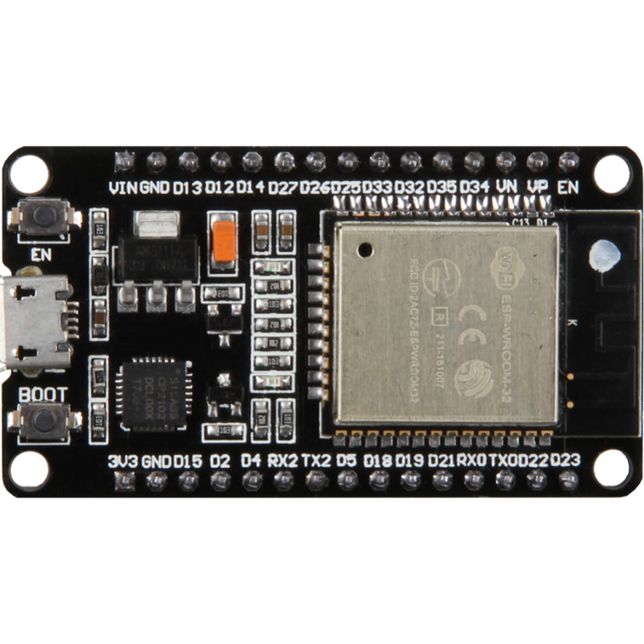

**Fig 3.2 ESP32 BORAD**

**Featured Solutions:**

**Ultralow Power Solution**

ESP32 is designed for mobile, wearable electronics, and Internet-of-Things (IoT) applications. It features all the state-of-the-art characteristics of low-power chips, including fine-grained clock gating, multiple power modes, and dynamic power scaling. For instance, in a low-power IoT sensor hub application scenario, ESP32 is woken up periodically and only when a specified condition is detected. Low-duty cycle is used to minimize the amount of energy that the chip expends. The output of the power amplifier is also adjustable, thus contributing to an optimal trade-off between communication range, data rate and power consumption.

**Complete Integration Solution**

ESP32 is a highly-integrated solution for Wi-Fi-and-Bluetooth IoT applications, with around 20 external components. ESP32 integrates an antenna switch, RF balun, power amplifier, low-noise receive amplifier, filters, and power management modules. As such, the entire solution occupies minimal Printed Circuit Board (PCB) area. ESP32 uses CMOS for single-chip fully-integrated radio and baseband, while also integrating advanced calibration circuitries that allow the solution to remove external circuit imperfections or adjust to changes in external conditions. As such, the mass production of ESP32 solutions does not require expensive and specialized Wi-Fi testing equipment.

**Wi-Fi Key Features**

802.11 b/g/n ,802.11 n (2.4 GHz), up to 150 Mbps ,WMM ,TX/RX A-MPDU, RX A-MSDU ,Immediate Block ACK, Defragmentation ,Automatic Beacon monitoring (hardware TSF), 4 × virtual Wi-Fi interfaces ,Simultaneous support for Infrastructure Station, Soft AP, and Promiscuous modes Note that when ESP32 is in Station mode, performing a scan, the Soft AP channel will be changed, Antenna diversity

**MCU and Advanced Features:**

**CPU and Memory:**

Xtensa® single-/dual-core 32-bit LX6 microprocessor(s), up to 600 MIPS (200 MIPS for ESP32-S0WD/ESP32-U4WDH, 400 MIPS for ESP32-D2WD) ,448 KB ROM , 520 KB SRAM ,16 KB SRAM in RTC, QSPI supports multiple flash/SRAM chips.

**Clocks and Timers:**

• Internal 8 MHz oscillator with calibration, Internal RC oscillator with calibration ,External 2 MHz ~ 60 MHz crystal oscillator (40 MHz only for Wi-Fi/BT functionality) ,External 32 kHz crystal oscillator for RTC with calibration ,Two timer groups, including 2 × 64-bit timers and 1 × main watchdog in each group , One RTC timer , RTC watchdog

**Fig 3.3 BLOCK DIAGRAM**

**Fig 3.4 PIN CONFIGURATION OF ESP32**

**CPU and Memory:**

**CPU:**

ESP32 contains one or two low-power Xtensa® 32-bit LX6 microprocessor(s) with the following features:

• 7-stage pipeline to support the clock frequency of up to 240 MHz (160 MHz for ESP32-S0WD, ESP32-D2WD, and ESP32-U4WDH)

• 16/24-bit Instruction Set provides high code-density

• Support for Floating Point Unit

• Support for DSP instructions, such as a 32-bit multiplier, a 32-bit divider, and a 40-bit MAC

• Support for 32 interrupt vectors from about 70 interrupt sources The single-/dual-CPU interfaces include:

• Xtensa RAM/ROM Interface for instructions and data

• Xtensa Local Memory Interface for fast peripheral register access

• External and internal interrupt sources

• JTAG for debugging

**Internal Memory:**

ESP32’s internal memory includes:

• 448 KB of ROM for booting and core functions

• 520 KB of on-chip SRAM for data and instructions

• 8 KB of SRAM in RTC, which is called RTC FAST Memory and can be used for data storage; it is accessed by the main CPU during RTC Boot from the Deep-sleep mode.

• 8 KB of SRAM in RTC, which is called RTC SLOW Memory and can be accessed by the co-processor during the Deep-sleep mode.

• 1 Kbit of effuse: 256 bits are used for the system (MAC address and chip configuration) and the remaining 768 bits are reserved for customer applications, including flash-encryption and chip-ID.

• Embedded flash

External Flash and SRAM:

ESP32 supports multiple external QSPI flash and SRAM chips. More details can be found in Chapter SPI in the ESP32 Technical Reference Manual. ESP32 also supports hardware encryption/decryption based on AES to protect developers’ programs and data in flash.

ESP32 can access the external QSPI flash and SRAM through high-speed caches.

• Up to 16 MB of external flash can be mapped into CPU instruction memory space and read-only memory space simultaneously.

– When external flash is mapped into CPU instruction memory space, up to 11 MB + 248 KB can be mapped at a time. Note that if more than 3 MB + 248 KB are mapped, cache performance will be reduced due to speculative reads by the CPU.

– When external flash is mapped into read-only data memory space, up to 4 MB can be mapped at a time. 8-bit, 16-bit and 32-bit reads are supported.

• External SRAM can be mapped into CPU data memory space. SRAM up to 8 MB is supported and up to 4 MB can be mapped at a time. 8-bit, 16-bit and 32-bit reads and writes are supported.

* + 1. FLEX SENSOR

DESCRIPTION

A flex sensor or bend sensor is a [sensor](https://en.wikipedia.org/wiki/Sensor) that measures the amount of [deflection](https://en.wikipedia.org/wiki/Deflection_(engineering)) or [bending](https://en.wikipedia.org/wiki/Bending). Usually, the sensor is stuck to the surface, and resistance of sensor element is varied by bending the surface. Since the resistance is directly proportional to the amount of bend it is used as [goniometer](https://en.wikipedia.org/wiki/Goniometer), and often called flexible potentiometer. Spectra Symbol's flex sensor is a 4.5” bendable substrate that gives higher resistance readings as it flexes to a tighter radius. This 10 KΩ sensor has low power requirements for its output feedback. The resistance can increase up to 5-times the base or flat state reading. Users can calculate the degree of flexure or the bend radius using resistance.

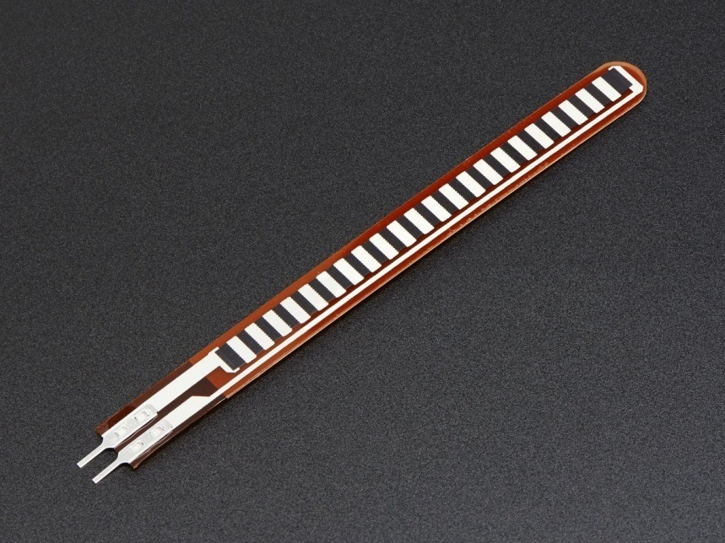

**Fig 3.5 FLEX SENSOR**

Common uses include measuring finger traction, robotics and gaming. The low profile of the flex sensor allows it to wrap around surfaces or to fit in tight spaces. With a life cycle of over 1 million flexes, its durability is suitable for many consumer applications.

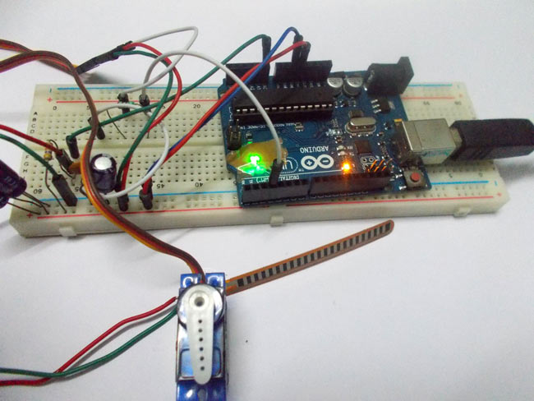

**Fig 3.6 FLEX SENSOR INTERFACE WITH CONTROLLER**

Flex sensors are passive resistive devices that can be used to detect bending or flexing. It is a bi-directional flex sensor that decreases its resistance in proportion to the amount it is bent in either direction. The Flex Sensor achieves great form-factor on a thin flexible substrate. When the substrate is bent, the sensor produces a resistance output correlated to the bend radius the smaller the radius, the higher the resistance value. It can be interfaced with the microcontroller unit. The output from the sensor is analog.

* + 1. HEART BEAT SENSOR

**DESCRIPTION**

The heartbeat sensor is based on the principle of photo phlethysmography. It measures the change in volume of blood through any organ of the body which causes a change in the light intensity through that organ (a vascular region). In case of applications where heart [pulse rate is to be monitored](http://www.edgefxkits.com/patient-health-monitoring-system-with-location-details-by-gps-over-gsm), the timing of the pulses is more important. The flow of blood volume is decided by the rate of heart pulses and since light is absorbed by blood, the signal pulses are equivalent to the heart beat pulses.

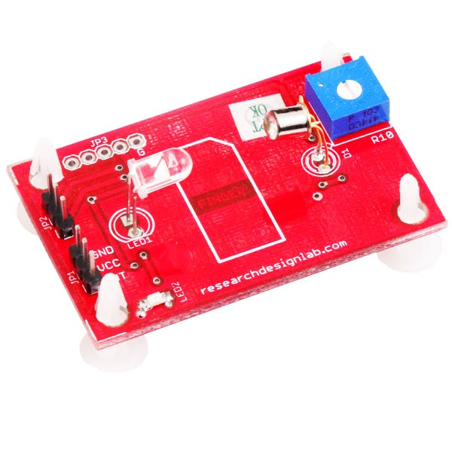

**Fig 3.7 HEARTBEAT SENSOR**

The operation of the board is very simple. After powering the board from a 3-5.5V supply, the Enable (EN) pin must be pulled high to activate the IR sensor. Next, place the tip of your forefinger gently over the sensor on its face. Your finger should be still and should not press too hard on the sensor. Within a couple seconds the circuit stabilizes and you will see the LED flashing synchronously with your heart beat. You can feed the output signal (Vought) to either a digital I/O or an ADC input pin of the microcontroller for measurement of the heart beat rate in BPM. The output voltage waveform can also be viewed on an oscilloscope. I connected Digi lent’s Analog Discovery tool to check the input PPG and the output waveforms from the two LPF stages.

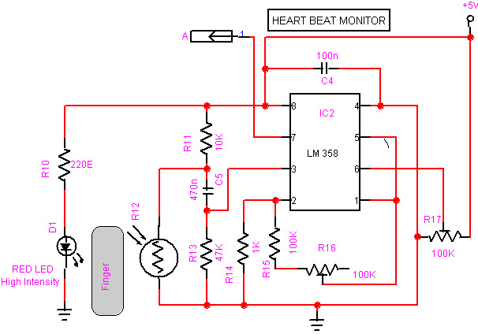

**Fig 3.8 CIRCUIT DIAGRAM**

Heart beat sensor works on a very basic principle of optoelectronics. All it takes to measure you heart rate is a pair of LED and LDR and a microcontroller. IR led emits infrared radiation and surface reflects the infrared light. Depending on reflectivity of the surface amount of light reflected varies this reflected light is made incident on reverse biased IR sensor which results in reverse leakage current. Amount of electron-hole pairs generated depends on intensity of incident IR radiation. More intense radiation results in more reverse leakage current. This current can be passed through a resistor to get proportional voltage. Thus as intensity of incident rays varies, voltage across resistor will vary accordingly.

* + 1. ADAPTER (12V 1AMP)

**DESCRIPTION**

An AC adapter, AC/DC adapter, or AC/DC converteris a type of external power supply, often enclosed in a case similar to an AC plug. Adapters for battery-powered equipment may be described as chargers or rechargers (see also battery charger). AC adapters are used with electrical devices that require power but do not contain internal components to derive the required voltage and power from main power. The internal circuitry of an external power supply is very similar to the design that would be used for a built-in or internal supply.

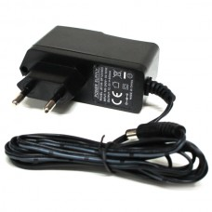

**Fig 3.9 ADAPTER (12V 1AMP)**

An adapter is a device that converts attributes of one electrical device or system to those of an otherwise incompatible device or system. Some modify power or signal attributes, while others merely adapt the physical form of one electrical connector to another. In a computer, an adapter is often built into a card that can be inserted into a slot on the computer's motherboard. The card adapts information that is exchanged between the computer's microprocessor and the devices that the card supports.

**CIRCUIT DIAGRAM**

An electric power adapter may enable connection of a power plug, sometimes called, used in one region to a AC power socket used in another, by offering connections for the disparate contact arrangements, while not changing the voltage. An AC adapter, also called a "recharger", is a small power supply that changes household electric current from distribution voltage) to low voltage DC suitable for consumer electronics. Some modify power or signal attributes, while others merely adapt the physical form of one electrical connector to another. For computers and related items, one kind of serial port adapter enables connections between 25-contact and nine-contact connectors, but does not affect electrical power- and signalling-related attributes

**Fig 3.10 SMPS CIRCUIT**

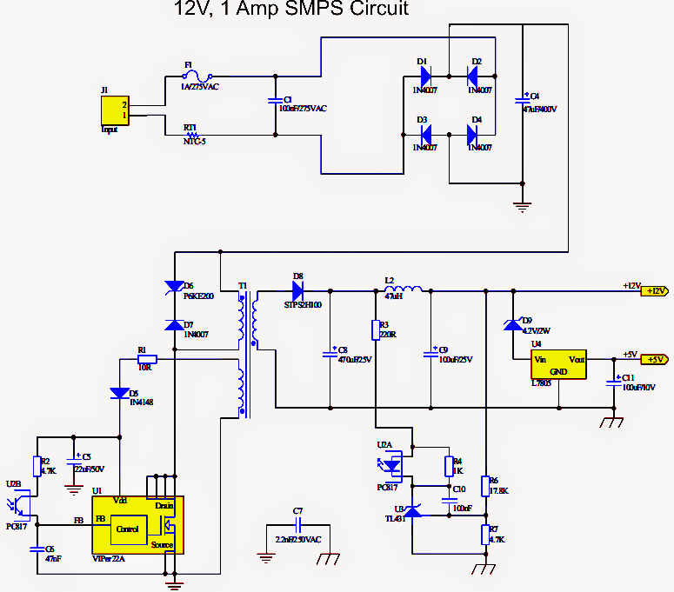

**INTERNET OF THINGS (IoT):**

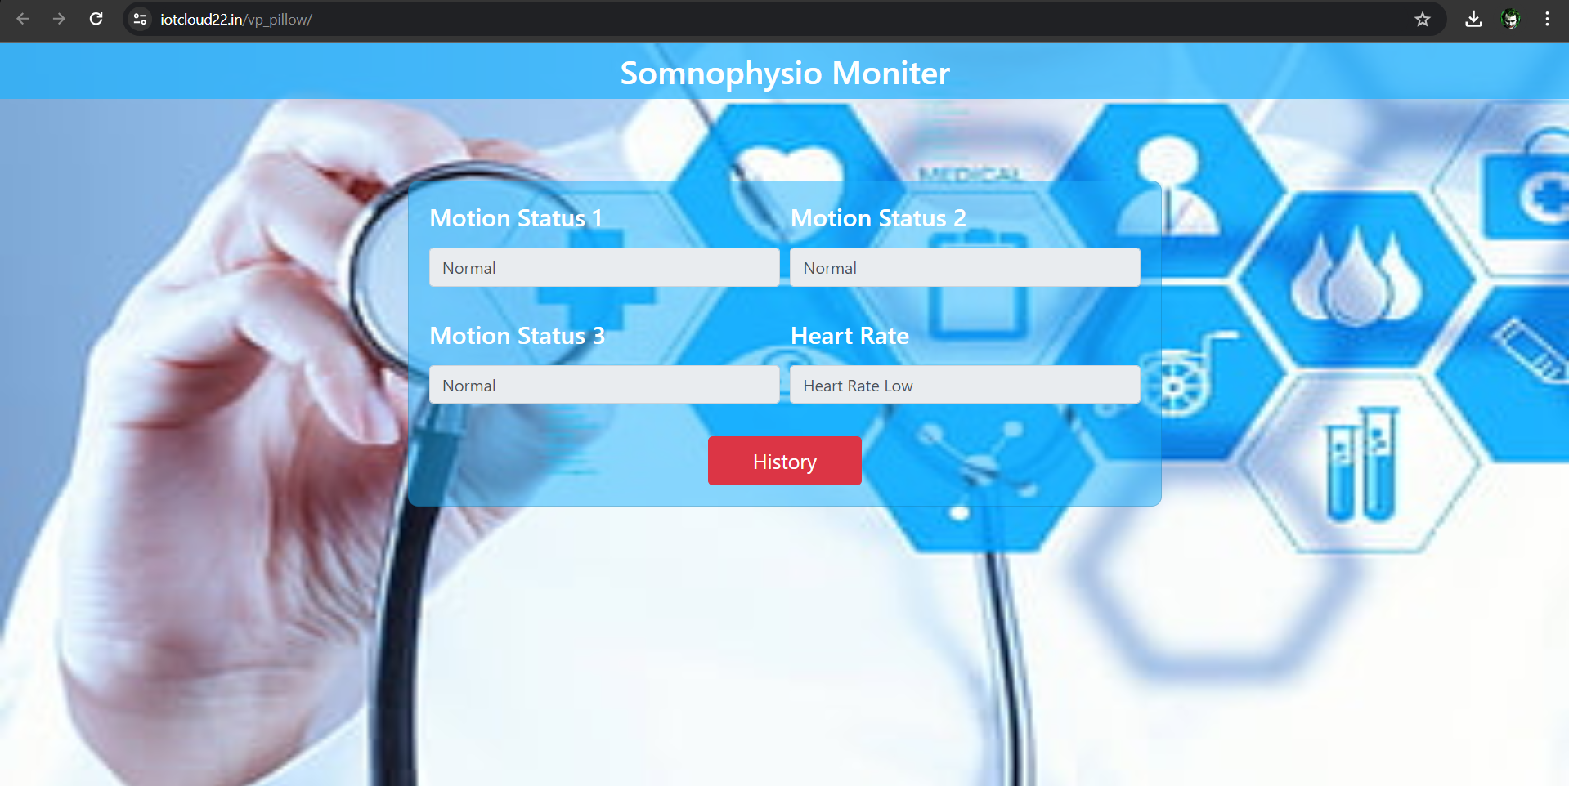

**Fig 3.11 WEB MONITOR**

The Internet of things (IoT) describes the network of physical objects “things” that are embedded with sensors, software, and other technologies for the purpose of connecting and exchanging data with other devices and systems over the Internet. Things have evolved due to the convergence of multiple technologies, real-time analytics, machine learning, commodity sensors, and embedded systems. Traditional fields of embedded systems, wireless sensor networks, control systems, automation (including home and building automation), and others all contribute to enabling the Internet of things. In the consumer market, IoT technology is most synonymous with products pertaining to the concept of the "smart home", including devices and appliances (such as lighting fixtures, thermostats, home security systems and cameras, and other home appliances) that support one or more common ecosystems, and can be controlled via devices associated with that ecosystem, such as smartphones and smart speakers. IoT can also be used in healthcare systems. The IoT is the strategy for gadgets that encase hardware, and network, which enables these devices to fix, act together and switch information. IoT incorporates broadening Internet beneficial than standard gadgets, for example, work areas to any decision of generally non web get to material gadgets and on a day by day source objects. Inserted through innovation, these gadgets can banter and coordinate over the Internet, and they can be a little checked and restricted.

**Fig 3.12 IoT of Somnophysio Monitor**

The Internet of Things (IoT) has revolutionized the way we interact with physical objects, enabling seamless connectivity and data exchange between devices. At the heart of this transformation lies the integration of cloud servers, which play a pivotal role in storing, processing, and managing the vast amounts of data generated by IoT devices. This three-page discussion will delve into the significance of cloud servers in IoT, their role in data storage, and the benefits they offer to various industries and applications.

Cloud servers serve as the backbone of IoT ecosystems, providing a centralized platform for storing and managing data generated by interconnected devices. By leveraging cloud-based storage solutions, IoT applications can overcome the limitations of on-device storage capacity and processing power, enabling scalable and flexible data management. Cloud servers act as repositories for sensor data, telemetry streams, and event logs, facilitating real-time analysis, predictive modelling, and historical trend analysis. Cloud servers offer virtually unlimited storage capacity, allowing IoT applications to scale seamlessly with growing data volumes. This scalability ensures that organizations can accommodate the exponential growth of IoT devices and data streams without the need for costly infrastructure upgrades. Additionally, cloud-based storage solutions provide flexibility in terms of storage configurations, allowing users to dynamically allocate resources based on changing requirements.

**Fig 3.13 Cloud Sever Data Storage**

Cloud-based data storage ensures ubiquitous access to IoT data from anywhere, at any time, and from any device. This accessibility enables real-time monitoring, remote management, and data-driven decision-making, empowering organizations to derive actionable insights from their IoT deployments. Moreover, cloud servers boast high availability and reliability, with redundant data centers and failover mechanisms ensuring uninterrupted access to critical data and services.

Cloud-based storage solutions offer a cost-effective alternative to traditional on-premises infrastructure, eliminating the need for upfront hardware investments and ongoing maintenance expenses. With pay-as-you-go pricing models, organizations can optimize their storage costs based on actual usage, avoiding overprovisioning and resource wastage. Additionally, cloud providers often offer tiered storage options, allowing users to optimize cost-performance trade-offs based on their specific needs. Cloud servers are instrumental in storing and processing sensitive healthcare data generated by wearable devices, medical sensors, and remote patient monitoring systems. By securely storing patient health records and telemetry data in the cloud, healthcare providers can facilitate remote patient monitoring, telemedicine consultations, and personalized treatment plans. Cloud-based analytics tools enable healthcare professionals to identify trends, predict health outcomes, and intervene proactively to improve patient outcomes.

Cloud servers play a central role in enabling the storage, processing, and management of data in IoT ecosystems. By providing scalable, flexible, and cost-effective storage solutions, cloud-based data storage empowers organizations across industries to harness the full potential of IoT technology. From smart home automation to industrial IoT and healthcare applications, cloud servers serve as the foundation for innovation, driving efficiency, productivity, and value creation in the connected world of IoT.

* 1. OVERVIEW

Algorithms and real-time signal processing techniques, the system enables intuitive control of the robotic claw, ultimately empowering individuals with CTS and RNP to interact with their environment autonomously and effectively. Through this research endeavour, we aim to contribute to the advancement of assistive technology solutions, fostering independence and improving the overall well-being of individuals living with motor impairments.

**CHAPTER 4**

**Fig 4.1 Code for ESP32**



**Fig 4.2 Sever code.**

Creating sensor system was a major development in real-time sleep monitoring. It allows for multi-dimensional understanding of sleep posture and physiological dynamics. This was made possible by using the latest technology that brings together things such as force-sensitive resistors based on PTF (polymer thick film) technology, Zigbee for wireless communication and advanced software algorithms. The system has shown great ability to understand very small details about how people sleep. The effectiveness of sensor system was proven through tests which covered every angle to capture every slight change in positioning during sleep hours; hence identifying specific kinds of sleeping habits. It is important that these measurements are accurate because they help us know more about an individual’s pattern of sleep which then makes it possible to come up with a way of dealing with the problem. Also, it has been found that there is a great deal of information provided by the pressure data gathered through these objects; this has been useful in classifying different stages where one can be during their slumber as well as pointing out early signs for any potential disorders associated with poor sleeping.

By keeping track on a person’s heart rate, respiration among other factors across varying periods when they are asleep; means this technology becomes very useful not only for health matters but also general monitoring purposes too therefore covering most areas. According to evaluations done so far, sensor system has performed beyond expectations becoming a good option as opposed to using other devices which might not give accurate results. Integration with computer programs has made it easier for doctors in hospitals to process huge amounts of information thus making it quicker when coming up specific decisions concerning individual patients based on their sleeping trends collected over time from these sensors placed around them while admitted within such facilities. Additionally, nurses will also find this tool helpful through its easy-to-use design features coupled with strong capabilities for managing diverse types of sleep-related data sets including but not limited : identifying anomalies.

Moreover, since it complies fully with established medical standards then any practitioner within any given setting should find no difficulty at all when making use of them into his/her work flow systems meaning there would be needful integration into general health care facility operations management plans especially during times where there seems to exist an increase towards cases related directly or indirectly with failure adequate rest periods taken among general populations within society.

Sensor system offers several advantages over traditional methods of sleep monitoring. Firstly, its non-intrusive nature eliminates the need for cumbersome equipment or invasive procedures, enhancing user comfort and compliance. Unlike conventional sleep monitoring devices that may disrupt sleep patterns or cause discomfort, the sensor objects seamlessly integrate into the sleep environment, allowing for natural and uninterrupted sleep cycles. This advantage is particularly beneficial for long-term monitoring applications, where user adherence and comfort are essential for accurate data collection.

Furthermore, sensor system provides real-time monitoring capabilities, enabling timely intervention and personalized care. By continuously analysing sleep posture, gestural movements, and physiological parameters, healthcare professionals can identify aberrant patterns or early signs of sleep disorders, facilitating prompt diagnosis and treatment. This proactive approach to sleep monitoring not only improves patient outcomes but also reduces healthcare costs associated with prolonged hospital stays or complications arising from undiagnosed sleep disorders. Another notable advantage of sensor system is its scalability and versatility. The modular design allows for customization and adaptation to various clinical or research settings, catering to diverse patient populations and study objectives. Whether deployed in hospital wards, sleep clinics, or home environments, sensor system can accommodate different monitoring needs and preferences, making it a versatile tool for healthcare providers and researchers alike. Despite its numerous advantages, sensor system is not without challenges and limitations. One significant challenge is the interpretation and validation of the data collected. While the system provides rich insights into sleep behaviour and physiological parameters, the sheer volume of data generated can overwhelm healthcare professionals, leading to difficulties in discerning meaningful patterns or anomalies. Addressing this challenge requires the development of robust data analysis algorithms and visualization techniques that prioritize relevancy and clarity, enabling efficient interpretation and decision-making.

Additionally, the accuracy and reliability of sensor system may be influenced by various factors such as environmental conditions, user variability, and technical limitations. For instance, variations in mattress firmness or ambient noise levels could affect the performance of pressure sensors, leading to discrepancies in data quality. Similarly, individual differences in sleep behaviour and movement patterns may pose challenges for gesture recognition algorithms, necessitating ongoing calibration and refinement to ensure optimal performance across diverse user demographics. Furthermore, while sensor system offers a non-intrusive alternative to traditional sleep monitoring devices, its effectiveness in capturing certain physiological parameters, such as oxygen saturation levels or brain activity, may be limited. Addressing these limitations may require the integration of complementary sensor technologies or collaborative efforts with other healthcare disciplines, such as neurology or respiratory medicine, to develop comprehensive monitoring solutions.

**CHAPTER 5**

**CONCLUSION AND FUTURE WORK**

**5.1 CONCLUSION**

We've come to the end of our examination of Sensor Systems and seen that this new technology is a game changer in the world of sleep monitoring. This means it can give us insight into what happens when we sleep at night by fitting the very latest sensors into something as every day as objects. One of the most attractive things about the sensor system is its ability to follow any movements our bodies make while we sleep which helps us understand our general wellbeing during rest. This means that individuals are provided with full information on their postural change and cardiopulmonary activity; they can therefore know more about these patterns so that they may use them for making healthy choices regarding their lives

Further still, instant collection and interpretation of data concerning one’s rate of sleep disturbance may be made available so as to arrest it in time. This may further imply that when potential health threats are identified at an early stage, people may take steps towards preventing such hazards if not risks altogether from becoming realities later on in life. Additionally, designed not to interfere with comfort or sleep patterns; unlike other methods used traditionally which sometimes interrupt users’ nightly routines such as waking up during dreams, etc., this system fits seamlessly into each person’s day leaving much room for continuous observation thereof Aside from helping individuals enhance their health, Sensor Objects System also has great potential for health practitioners and researchers too. The information gathered through these devices could form the basis by which various types of sleep disorders might be recognized thereby leading to different kinds of treatments; it could also be utilized as an avenue through which unique patient plans are made known thus furthering sleep medicine advancement. Altogether it is undeniable that this invention marks a significant improvement in monitoring one's sleeping time health especially when put up against what was used before now. This new “sensor pillow” technology not only offers better understanding but also acts as a powerful tool for ensuring good sleep by using state-of-the-art sensors alongside a user-friendly design that can be used in modern-day sleep hygiene practices.

**5.2 FUTURE SCOPE**

**Enhanced Sensor Technology:**

Investigate the integration of advanced sensor technologies, such as capacitive sensors or photoplethysmography (PPG), to improve the accuracy and reliability of physiological parameter monitoring. Explore the use of novel materials and fabrication techniques to develop more comfortable and durable sensor arrays for long-term sleep monitoring.

**Machine Learning and AI Algorithms:**

Develop machine learning algorithms capable of analysing complex sleep data to provide personalized insights and recommendations for improving sleep quality. Explore the use of artificial intelligence (AI) techniques, such as deep learning, for real-time gesture recognition and sleep stage classification based on sensor data.

**Integration with Wearable Devices:**

Investigate the integration of sleep monitoring capabilities into wearable devices, such as smartwatches or fitness trackers, to enable continuous and unobtrusive monitoring of sleep parameters. Explore methods for synchronizing data collected from sensor objects with data collected from wearable devices to provide a comprehensive view of an individual's sleep patterns.

**Telemedicine and Remote Monitoring:**

Explore the potential for telemedicine applications by integrating the sleep monitoring system with remote communication technologies, allowing healthcare professionals to remotely monitor patients' sleep patterns and intervene when necessary. Develop user-friendly mobile applications that allow individuals to track their sleep quality and receive personalized recommendations for improving sleep hygiene based on the data collected by the system.

**Longitudinal Studies and Clinical Trials:**

Conduct longitudinal studies to evaluate the long-term efficacy and usability of the sleep monitoring system in diverse populations, including individuals with sleep disorders and chronic health conditions. Design randomized controlled trials to assess the effectiveness of interventions guided by the data collected from the system in improving sleep outcomes and overall health.

**Scalability and Commercialization:**

Explore strategies for scaling up the production of sensor objects systems to meet growing demand in healthcare facilities and consumer markets. Collaborate with industry partners to commercialize the sleep monitoring system and make it accessible to a wide range of users, including healthcare providers, sleep clinics, and individual consumers.

**Interdisciplinary Research and Collaboration:**

Foster interdisciplinary collaborations between engineers, sleep scientists, clinicians, and data scientists to leverage expertise from diverse fields and accelerate innovation in sleep monitoring technology. Encourage research institutions and funding agencies to support interdisciplinary research projects focused on improving.

Moving forward, there are several avenues for further research and development to enhance the capabilities and applicability of the sensor objects system. One promising direction is the integration of artificial intelligence (AI) and machine learning algorithms to improve data analysis and pattern recognition. By leveraging AI-driven analytics, sensor system can autonomously identify trends, predict outcomes, and provide actionable insights in real-time, empowering healthcare professionals with augmented decision-making capabilities. Moreover, advancements in sensor technology and miniaturization hold promise for expanding the scope of monitored parameters and enhancing user experience. Future iterations of sensor system may incorporate additional sensors, such as pulse oximeters or EEG electrodes, to capture a broader range of physiological signals and provide comprehensive sleep assessments. Furthermore, innovations in wearable technology and remote monitoring platforms may enable seamless integration with the sensor objects system, allowing for continuous monitoring beyond the confines of the sleep environment.Collaboration with industry partners and stakeholders is essential for accelerating the translation of research findings into practical applications and commercialization opportunities. By fostering interdisciplinary collaborations and engaging with end-users throughout the design and development process, sensor system can be tailored to meet the specific needs and preferences of healthcare providers, patients, and researchers, ensuring widespread adoption and impact.

In conclusion, sensor system represents a transformative approach to sleep monitoring, offering unparalleled insights into sleep behaviour and physiological dynamics. While challenges and limitations remain, ongoing research and innovation hold the key to unlocking its full potential and realizing its promise as a cornerstone of personalized healthcare technology. By embracing emerging technologies, fostering collaboration, and prioritizing user-centric design principles, sensor system is poised to revolutionize the way we monitor and manage sleep health, ultimately enhancing the well-being and quality of life for individuals worldwide.

REFERENCES

[1] T. Harada, T. Sato, and T. Mori, “Pressure distribution image based human motion tracking system using skeleton and surface integration

[2] M. Folke, L. Cernerud, M. Ekström, and B. Hök, “Critical review of non-invasive respiratory monitoring in medical care,” Med Bio Engin Comp, vol. 41, pp. 377-383, 2003.

[3] T. Harada, A. Sakata, T. Mori, and T. Sato, “Sensor System: monitoring respiration and body movement in sleep,” IEEE International Conference on Intelligent Robots and Systems, vol. 1, pp. 351-356, 2000.

[4] R. Wolk, A. S. Gami, A. Garcia-Touchard and V. K. Somers, “Sleep and cardiovascular disease,” Curr. Probl. Cardiol, vol. 30 pp. 625-662, 2005.

[5] X. Zhu, W. Chen, T. Nemoto, Y. Kanemitsu, K. Kitamura, K. Yamakoshi, and D. Wei, “Real-time monitoring of respiration rhythm and pulse rate during sleep,” IEEE Trans Biomed Eng, vol. 53 pp. 2553- 2563, 2006.

[6] W. Chen, X. Zhu, T. Nemoto, Y. Kanemitsu, K. Kitamura, K Yamakoshi, “Unconstrained detection of respiration rhythm and pulse rate with one under-objects sensor during sleep,” Med Biol Engin Comp, vol. 43 pp. 306-312, 2005.

[7] K. H. Park, Z. Bien, J. J. Lee, B. K. Kim, J. T. Lim, J. O. Kim, H. Lee, D. H. Stefanov, D. J. Kim and J. W. Jung, et al., “Robotic smart house to assist people with movement disabilitie,” Auton Robot, vol. 22, pp. 183- 198, 2007.

[8] Y. Nishida, M. Takeda, T. Mori, H. Mizoguchi, T. Sato, “Monitoring Patient Respiration and Posture Using Human Symbiosis System,” Proc. Of the 1997 IEEE/RSJ International Conference on Intellingent Robot and Systems, vol. 2, pp. 405-406, 1997.

[9] J. Alametsä, E. Rauhala, E. Huupponen, A. Saastamoinen, A. Värri, A. Joutsen, J. Hasan, and S. Himanen, “Automatic detection of spiking events in EMFi sheet during sleep,” Medical Engineering & Physics, vol. 28, pp. 267–275, 2006.

[10] S. J. Redmond and C. Heneghan, "Cardiorespiratory-Based Sleep Staging in Subjects With Obstructive Sleep Apnea," IEEE Transactions on Biomedical Engineering, vol. 53, no. 3, March 2006.

[11] J. Alihanka, K. Vaabmranta. and I. Saarikivi, “A New Long-term Monitoring of Ballistocardiogram, Heart Reat, and Respiration,” AM. J. Physiol., vol. 240, pp. 384-392, 1981.

[12] T. Watanabe and K. Watanabe, "Noncontact Method for Sleep Stage Estimation," IEEE Transactions on Biomedical Engineering, vol. 51, no 10, Oct., 2004.robotic wheelchair and smart environment,” IFAC-PapersOnLine, vol. 48, pp. 136–141, 2015.

[13] R. Zhang, S. He, X. Yang, X. Wang, K. Li, Q. Huang, Z. Yu, X. Zhang, D. Tang, and Y. Li, “An eog-based human–machine interface to control a smart home environment for patients with severe spinal cord injuries,” IEEE Transactions on Biomedical Engineering, vol. 66, pp. 89–100, 2018.